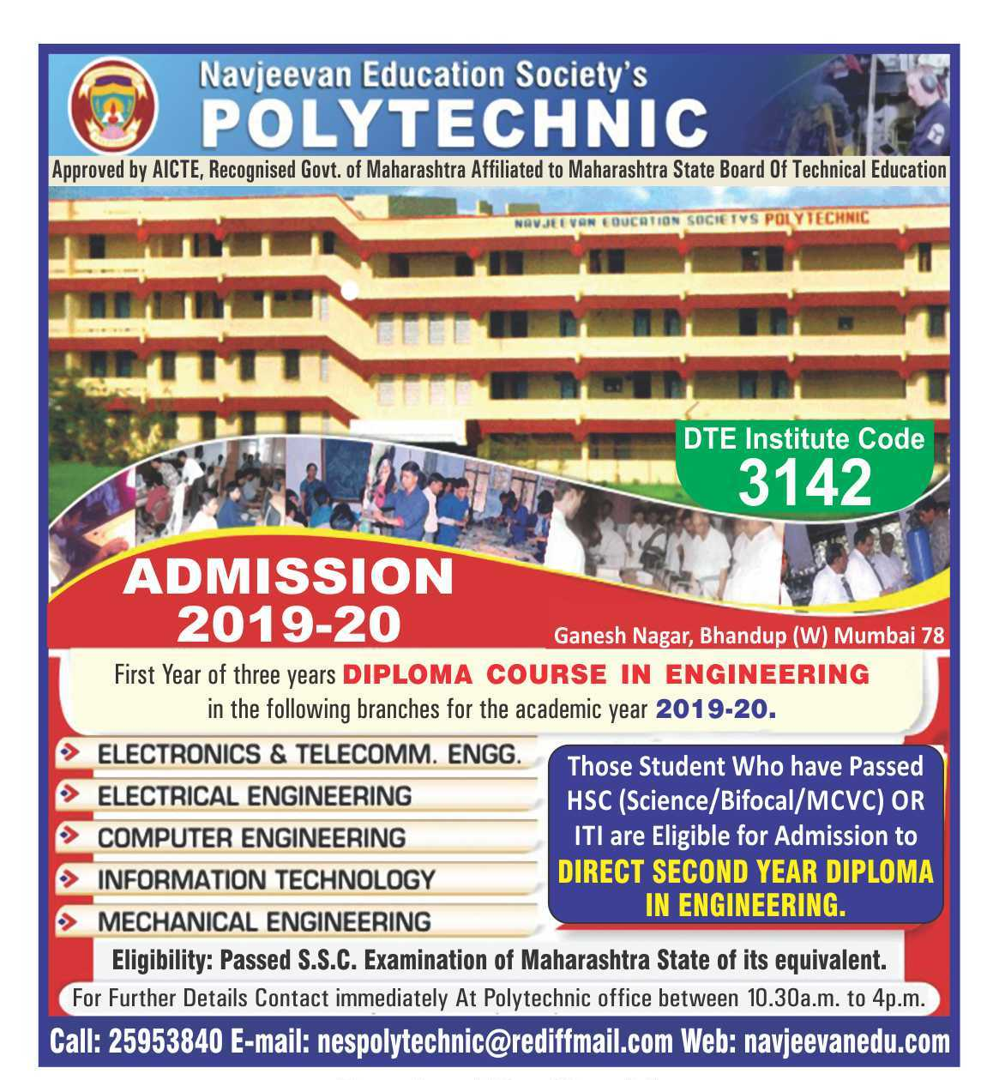

**NAVJEEVAN EDUCATION SOCIETY’S**

.POLYTECHNIC

DTE CODE-3142

Ganesh Nagar , Bhandup (w) , Mumbai- 400078.

###### Approved by AICTE , Recognised by GOVT. of Maharashtra

**Affiliated To Maharashtra State Board of Technical Education.**

ADMISSION NOTICE 2019 –20

Applications are invited from eligible candidates who have confirmed CAP / NON CAP application for admission to **First Year & Direct Second year** of three years **Diploma Courses in Engineering** to **Institute level Admission and Vacant Seats After CAP round** in the following branches for the academic year **2019-2020.**

|  |
| --- |
| **Courses** |
| **MECHANICAL ENGINEERING** |
| **ELECTRICAL ENGINEERING** |
| **COMPUTER ENGINEERING** |
| **INFORMATION TECHNOLOGY** |
| **ELECTRONICS & TELECOMM. ENGG.** |

***Free facility to fill option form for all cap rounds are available.***

**Application forms & prospectus** are available during office hours on payment of Rs. 500/- for First Year & Rs. 200 for Direct Second Year in cash.

* Raging is totally banned in our institute. Any one found guilty of ragging or abetting ragging is liable to be punished.

**For further details contact the undersigned immediately at polytechnic office between 10.30 A. M. to 4.00 P. M.**

**Phone- 022-2953840 E-mail :** [nespolytechnic@rediffmail.com](mailto:nespolytechnic@rediffmail.com) **Web:** www.navjeevanedu.com

**Secretary Principal**